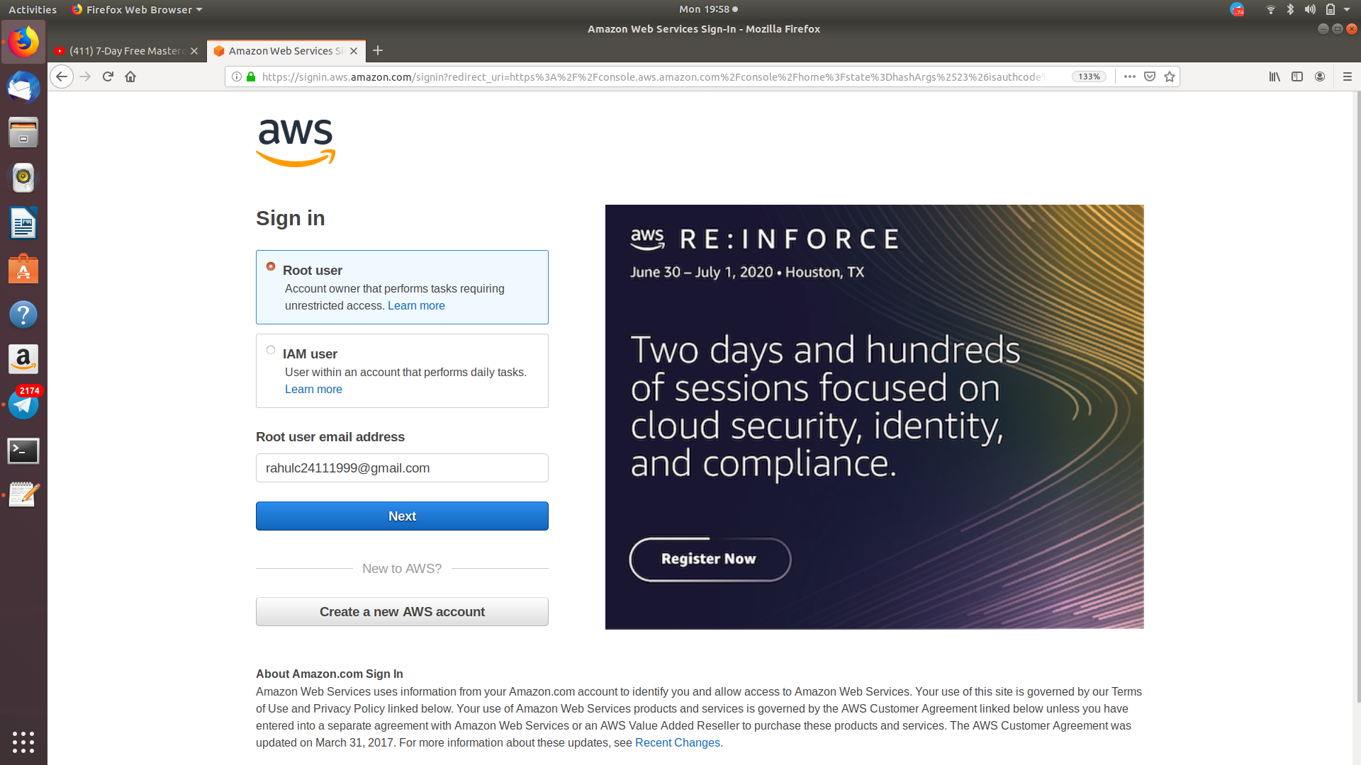

Screenshot:1 – Login Screen

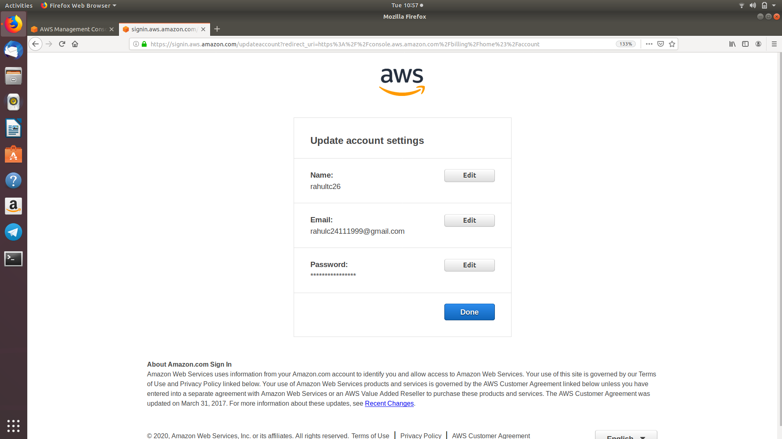

Screenshot:1.1 – Account confirmation

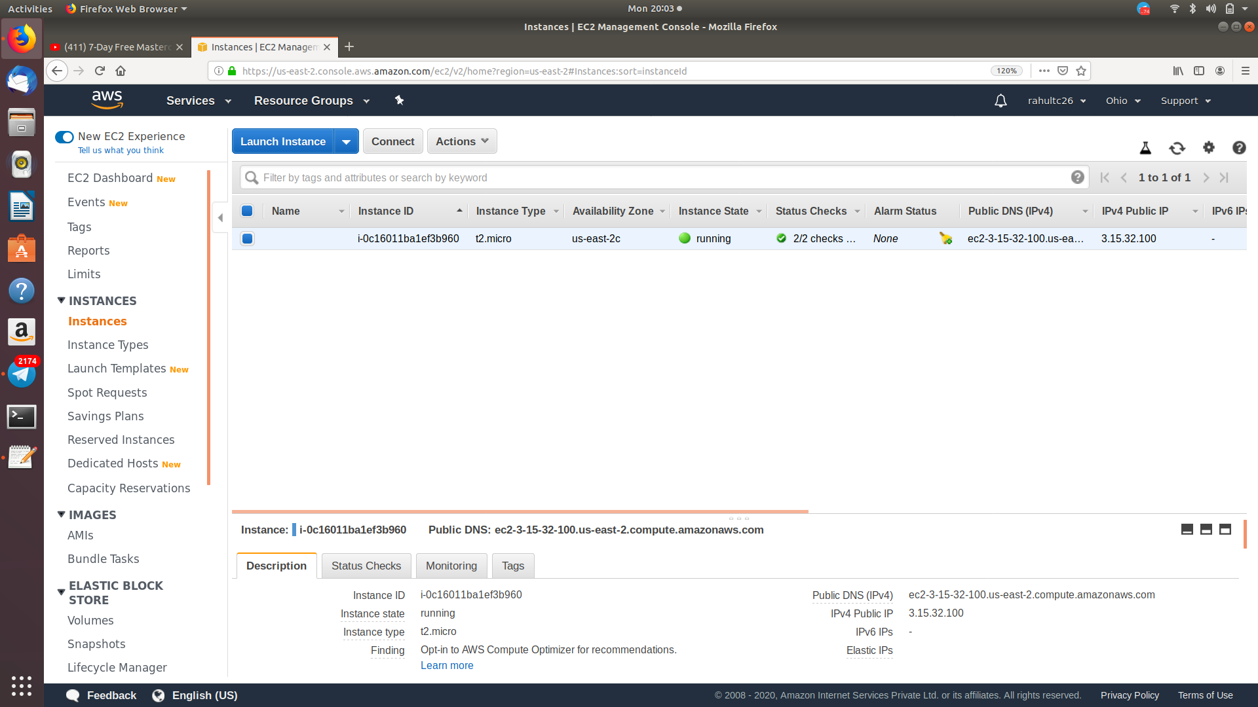

Screenshot:2 – EC2 Dashboard

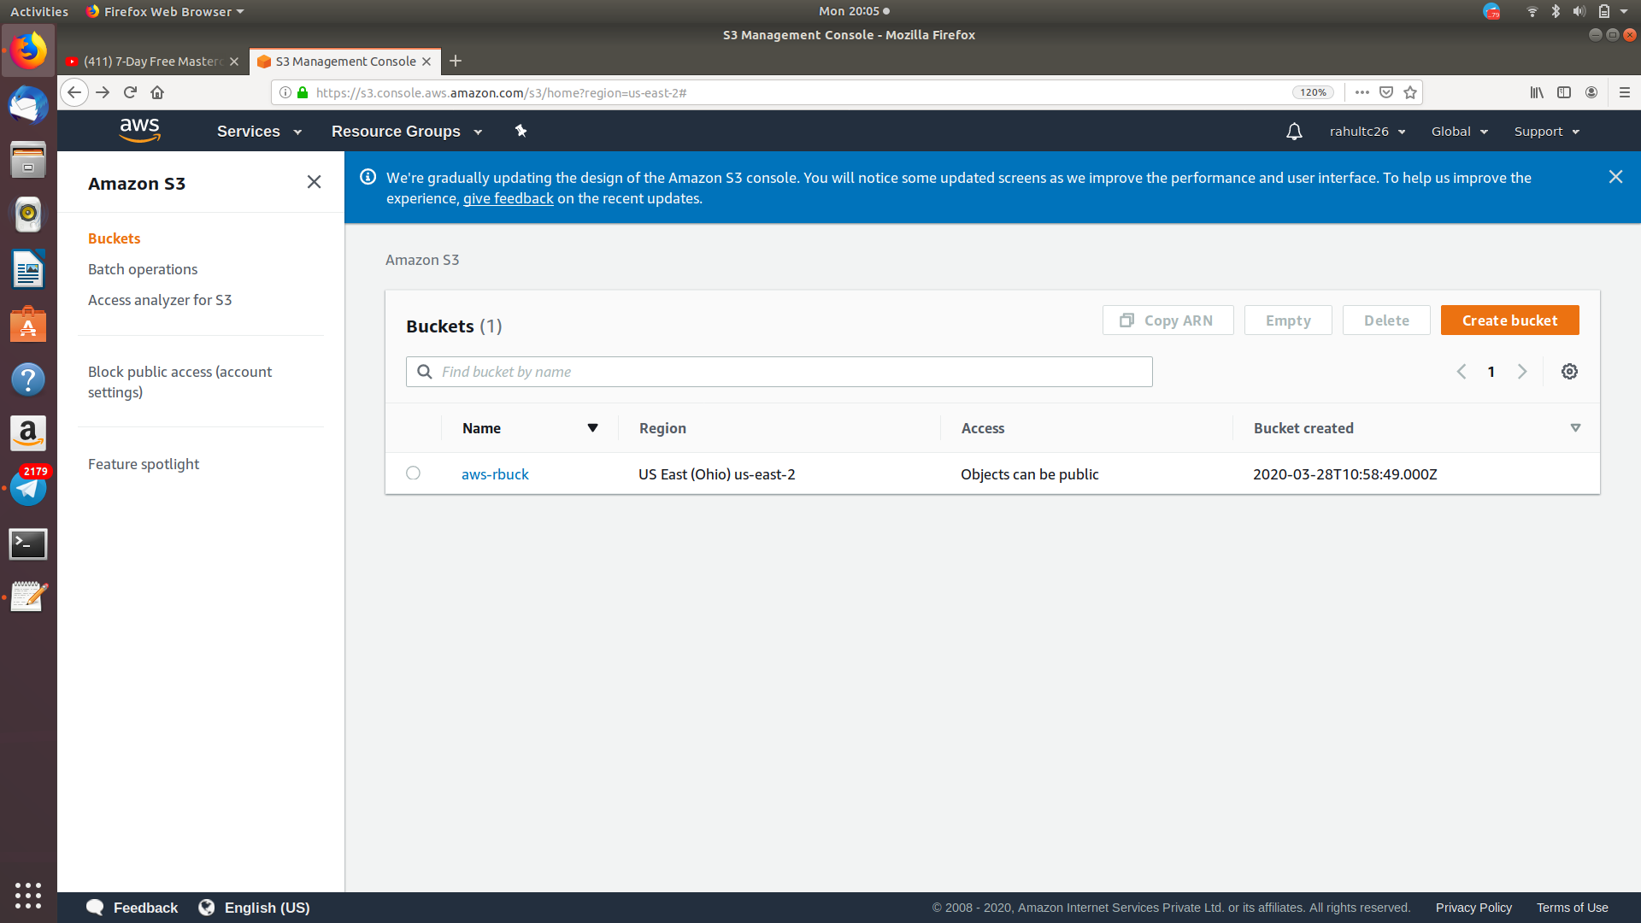

Screenshot:3 – S3 Dashboard

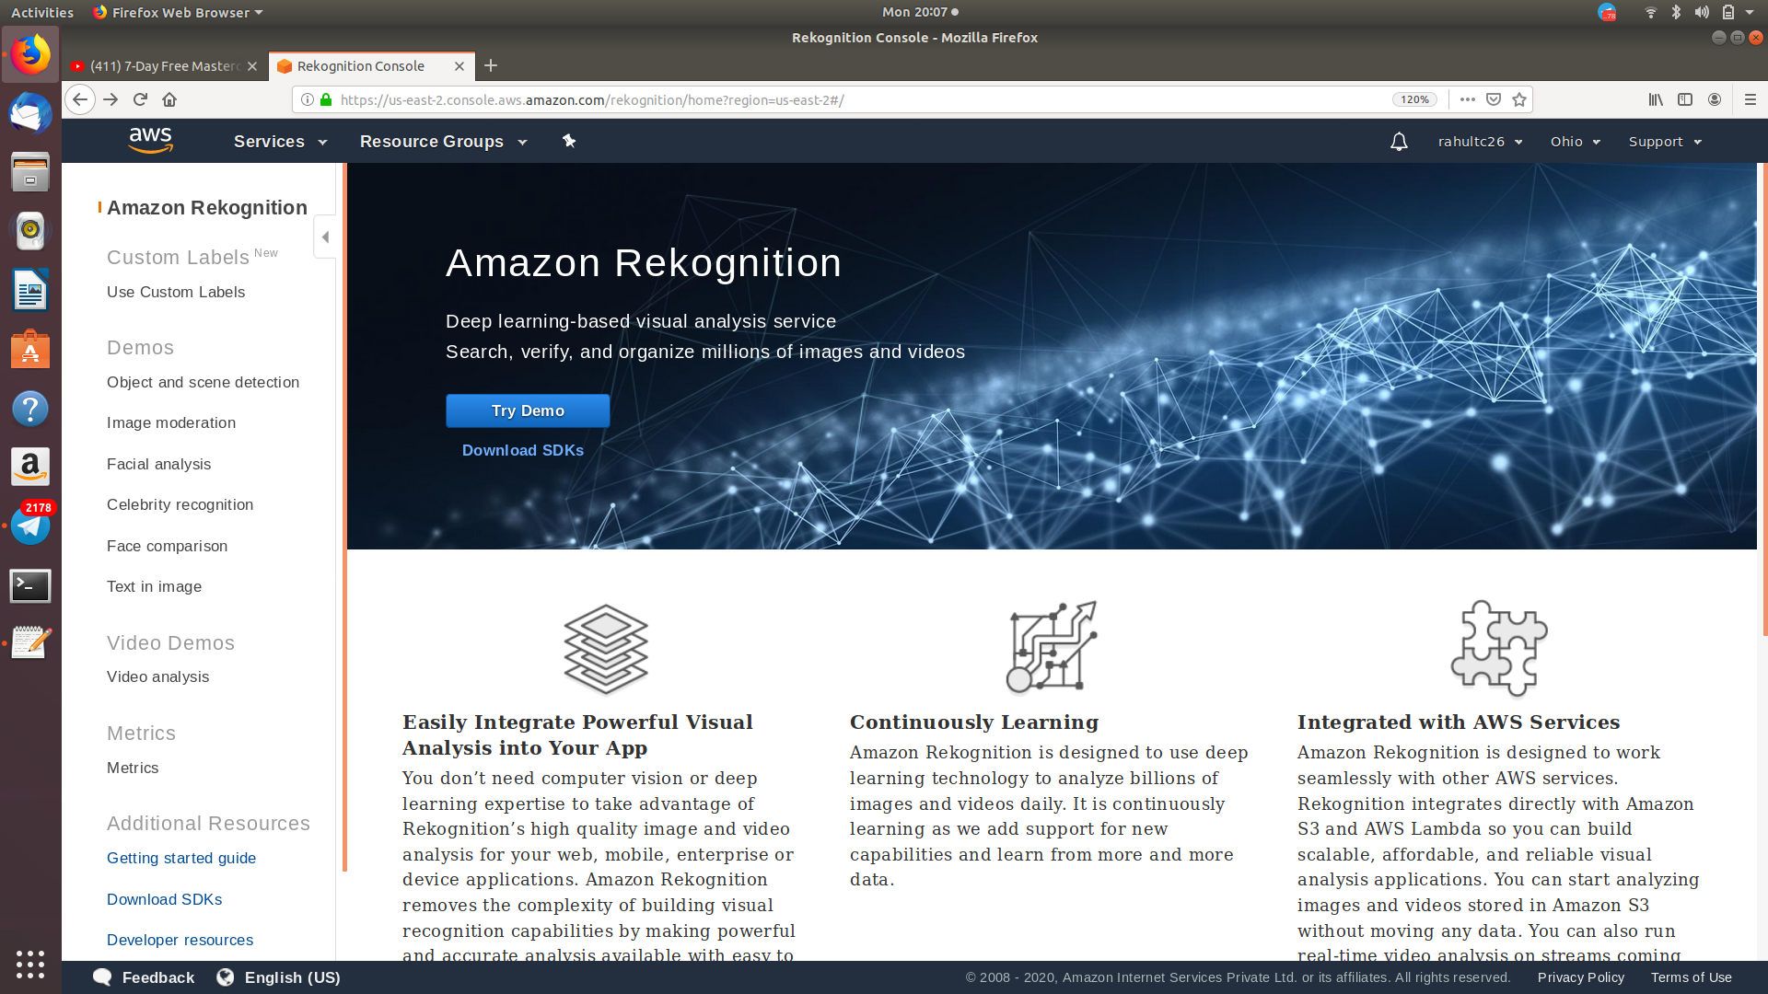

Screenshot:4 – Rekognition Dashboard

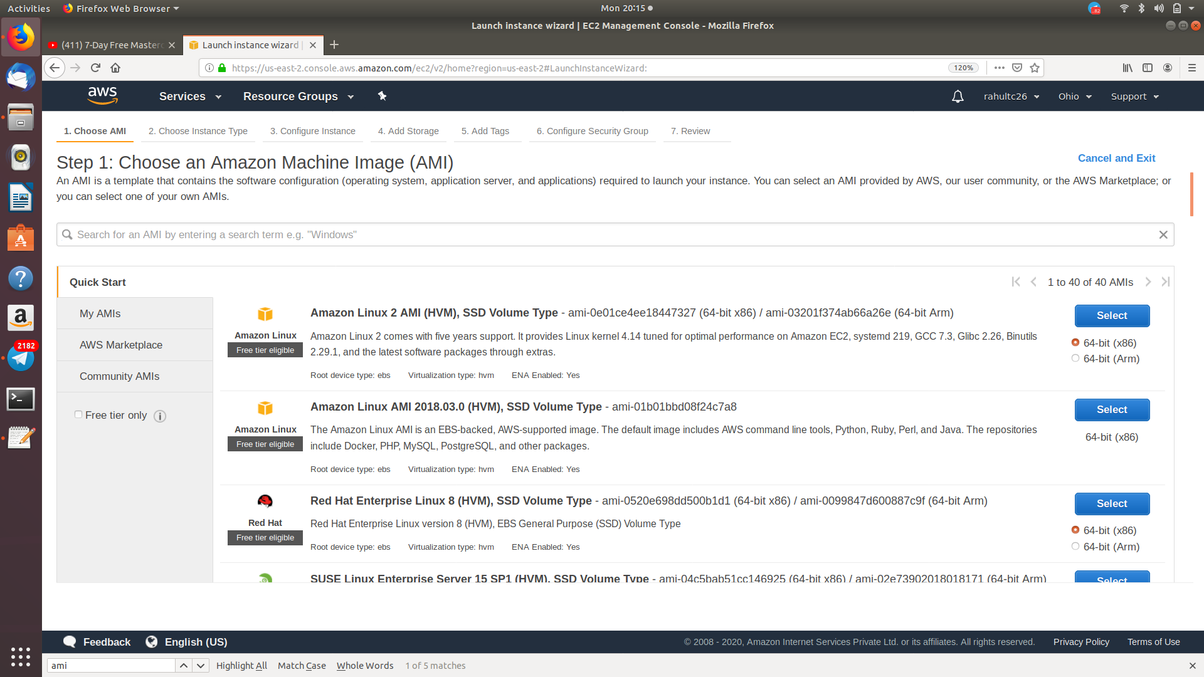

Screenshot:5 – Choosing an AMI

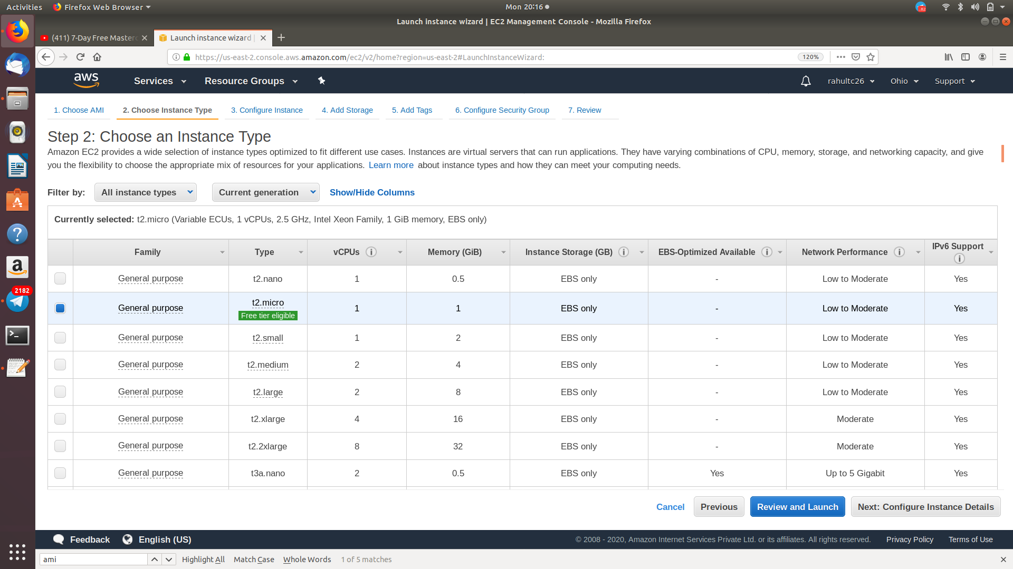

Screenshot:6 – Choosing an Instance Type

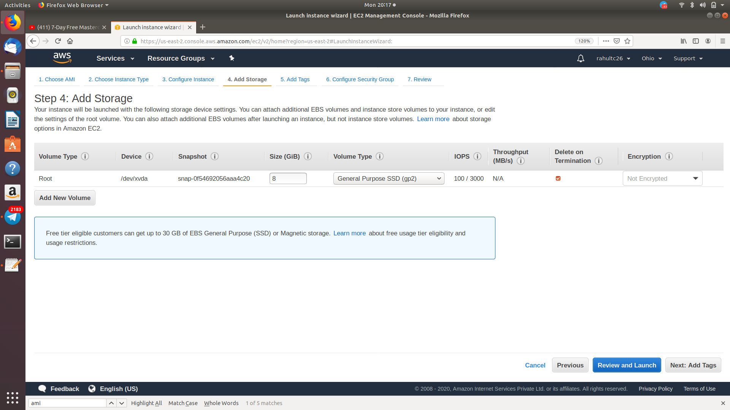

Screenshot:7 – Adding Storage

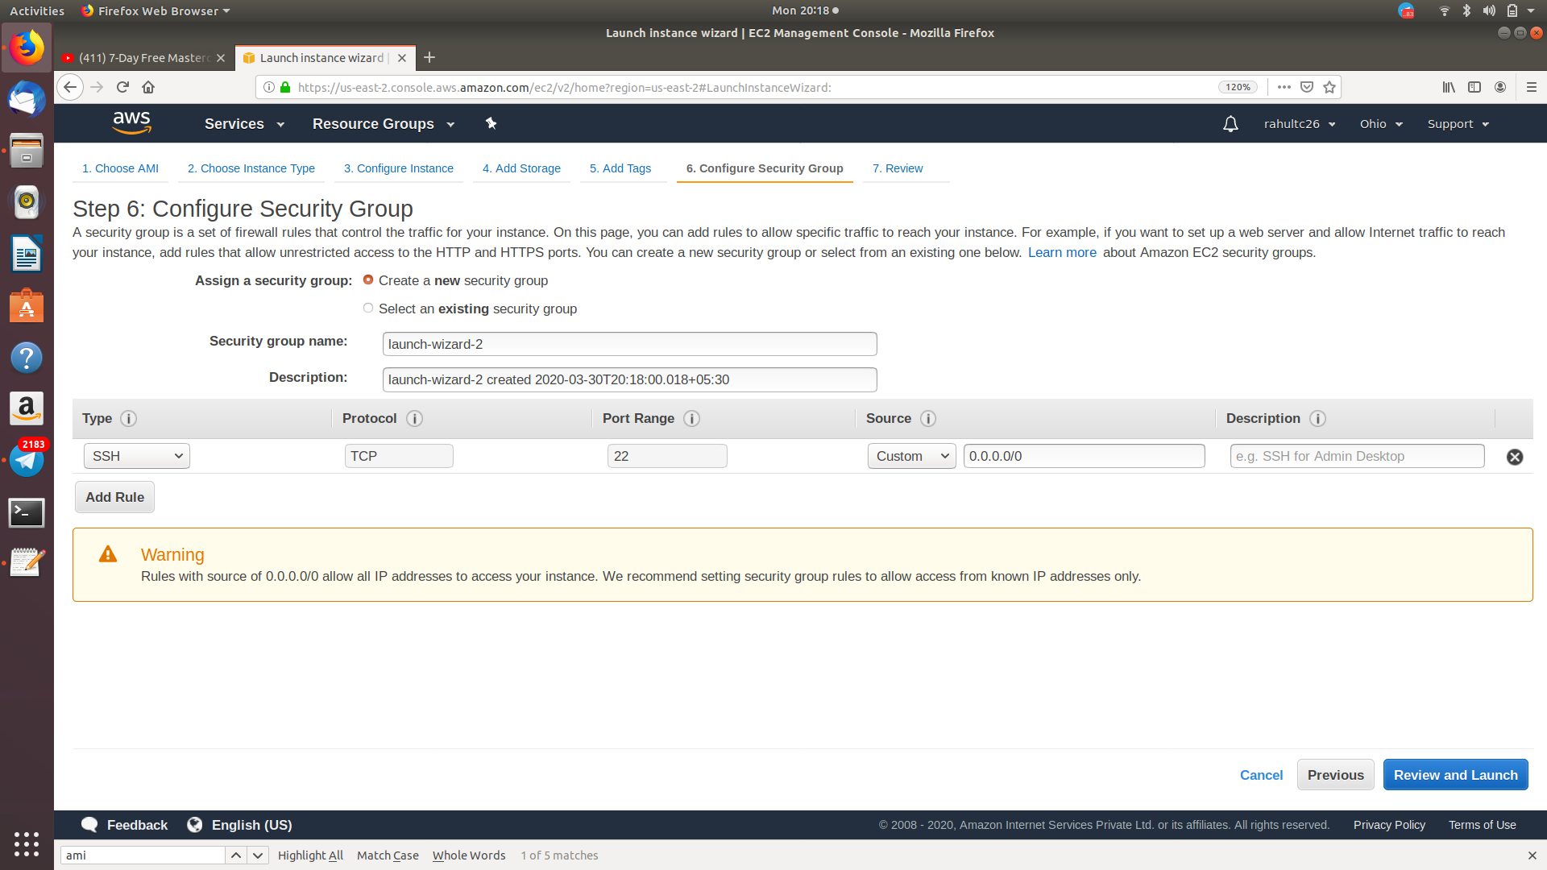

Screenshot:8 – Configuring Security Group

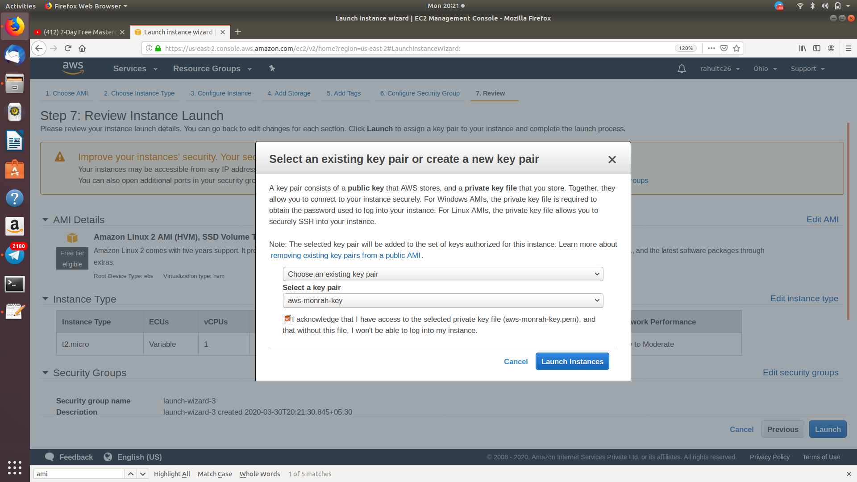

Screenshot:9 – Key Pair Download

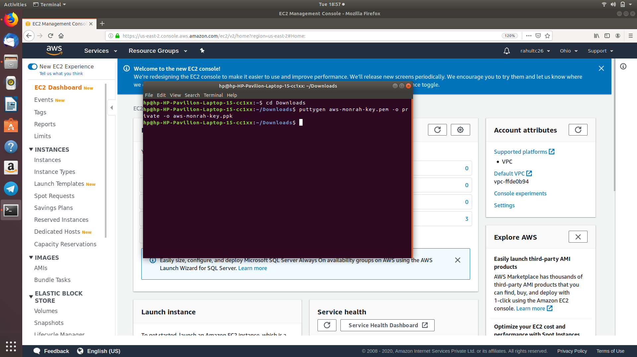

Screenshot:10 – Conversion from pem to ppk

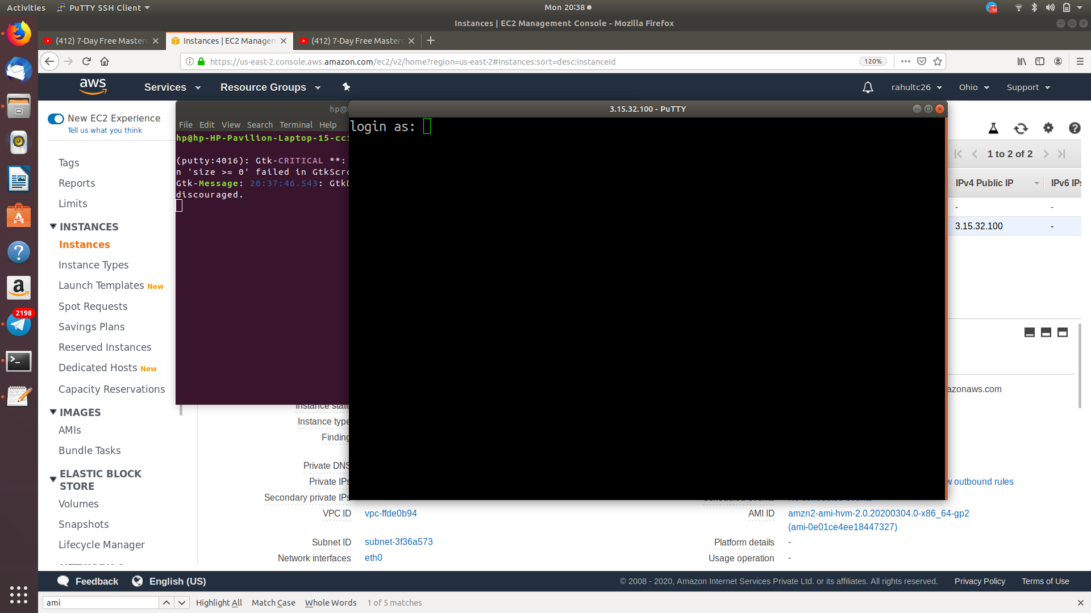

Screenshot:11 – Logged in EC2 Black Screen

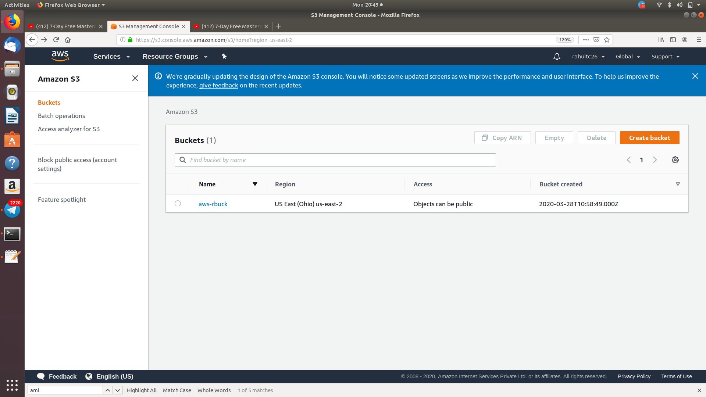

Screenshot:12 – Creating Bucket

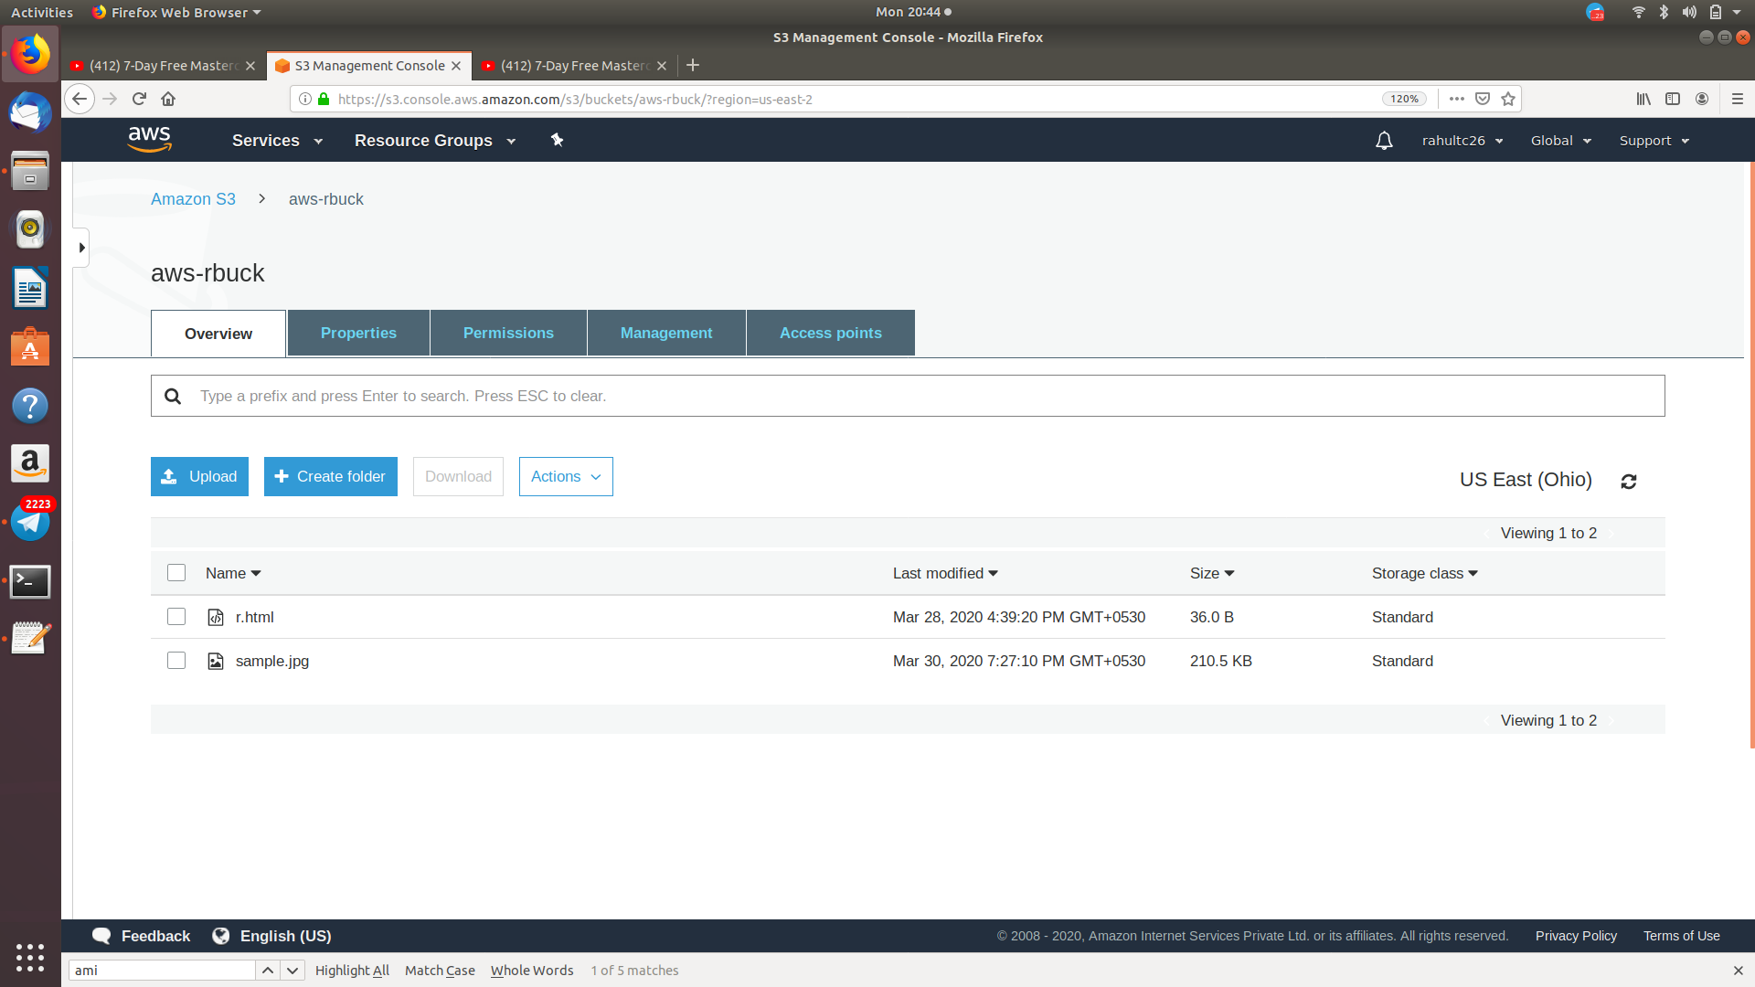

Screenshot:13 – Uploading Objects

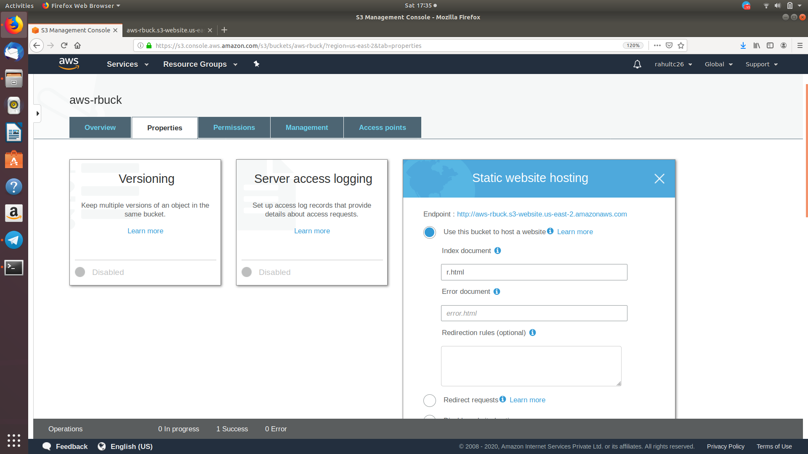

Screenshot:14 – Enabling Static Website

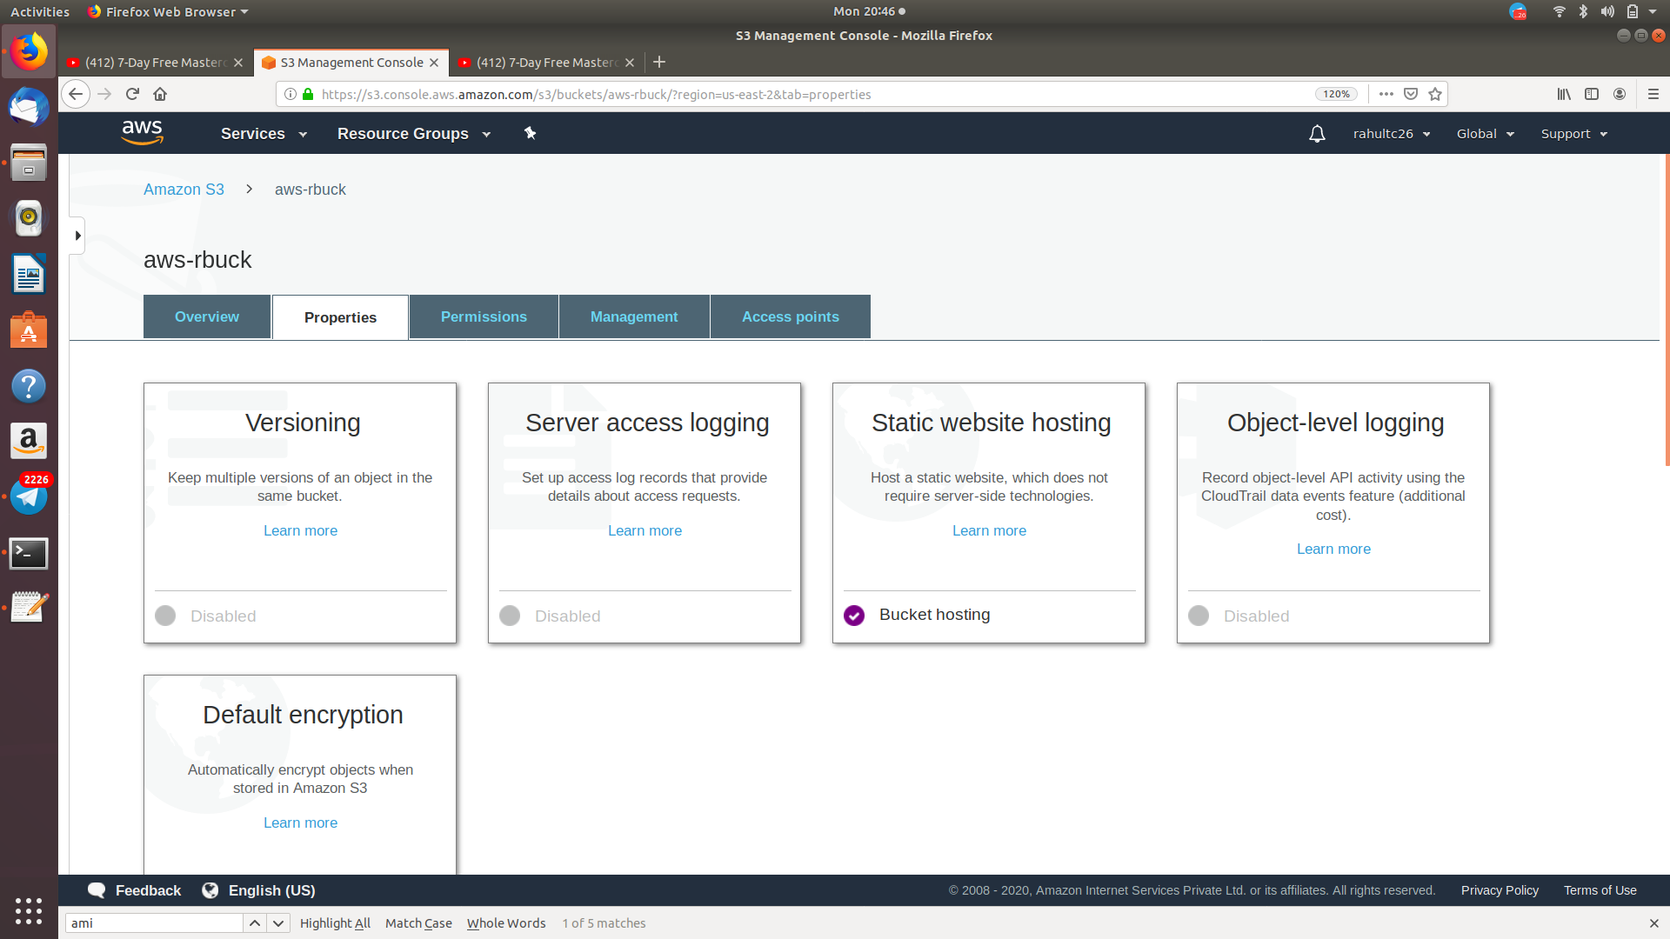

Screenshot:14.1 – After Enabling Static Website

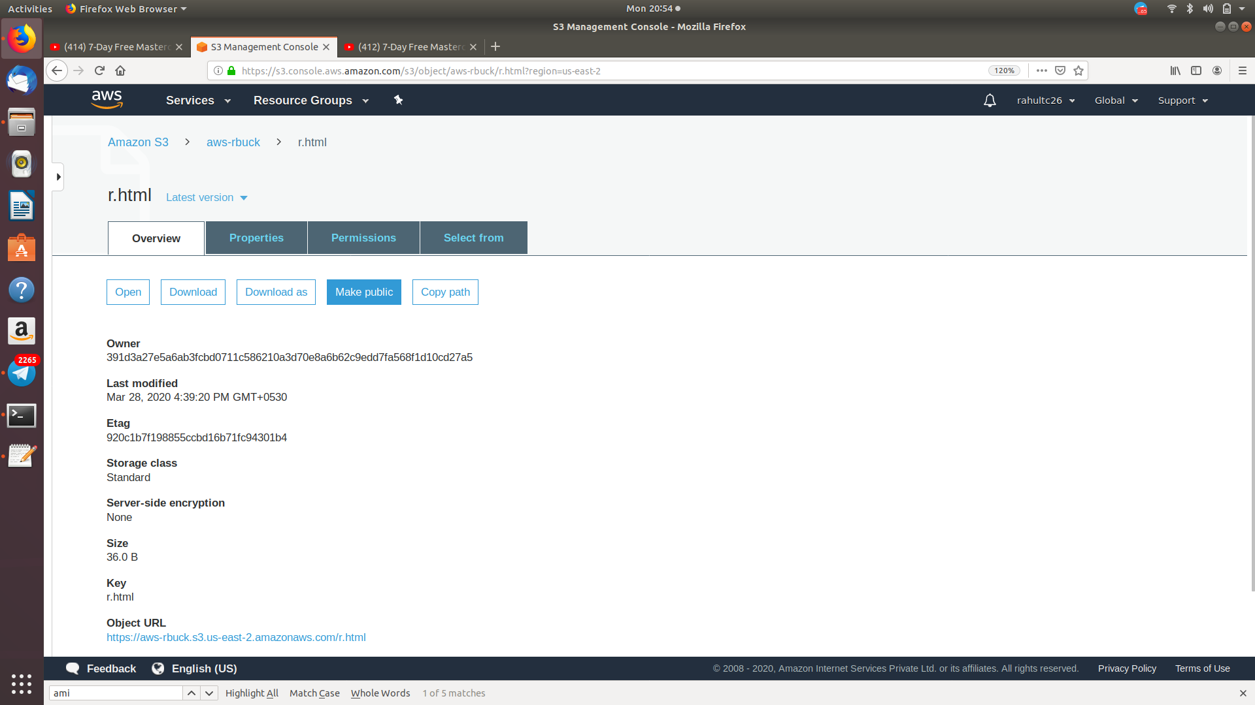

Screenshot:15 – Making the object Public

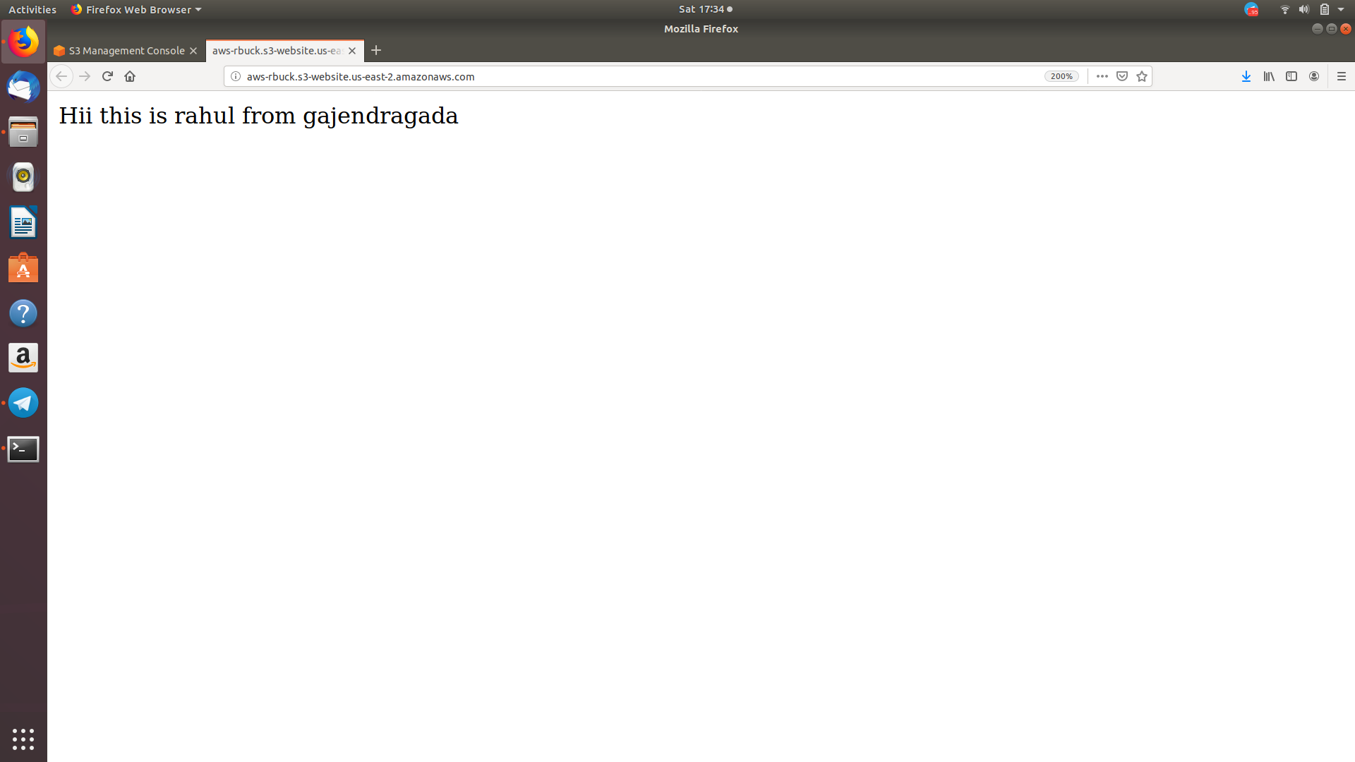

Screenshot:16 – Checking the S3 link on Browser

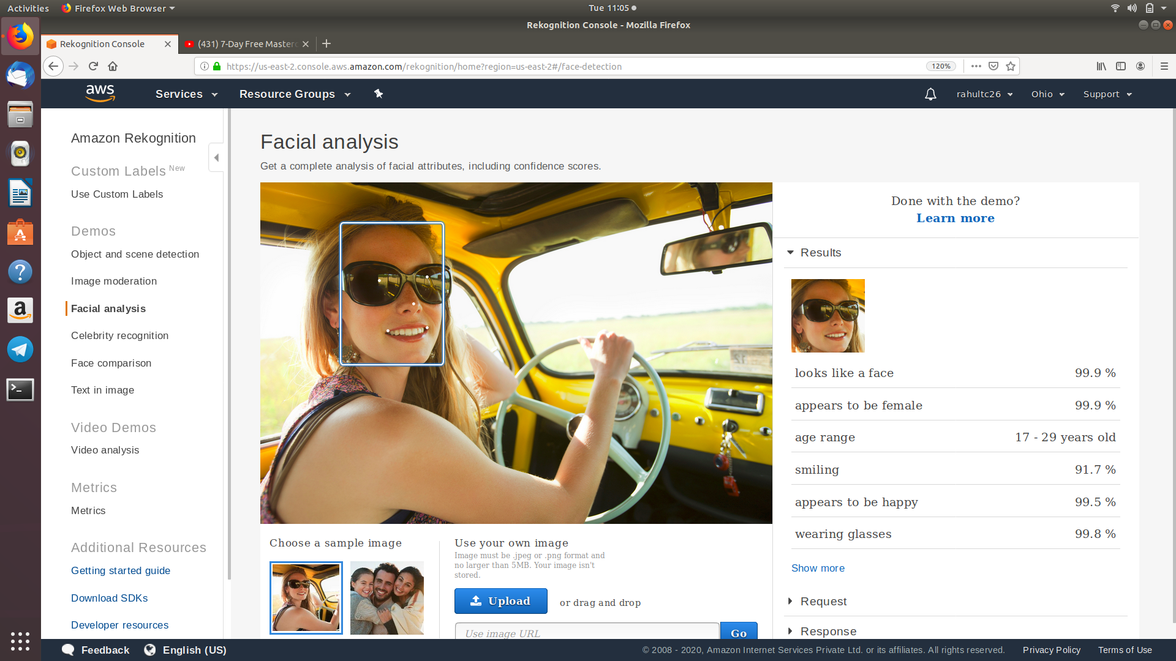

Screenshot:17 – Face Detection

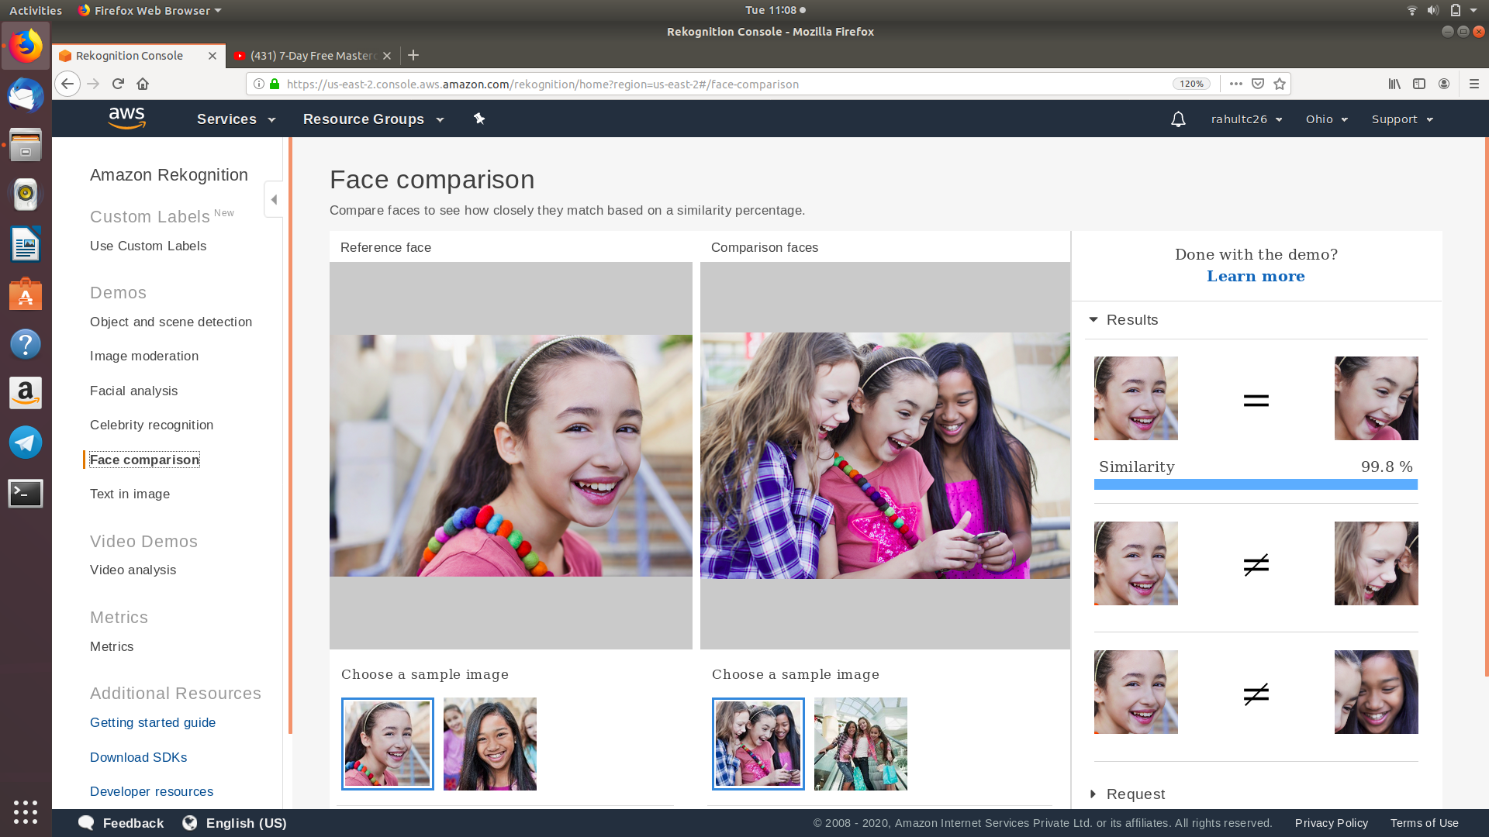

Screenshot:18 – Face Comparison

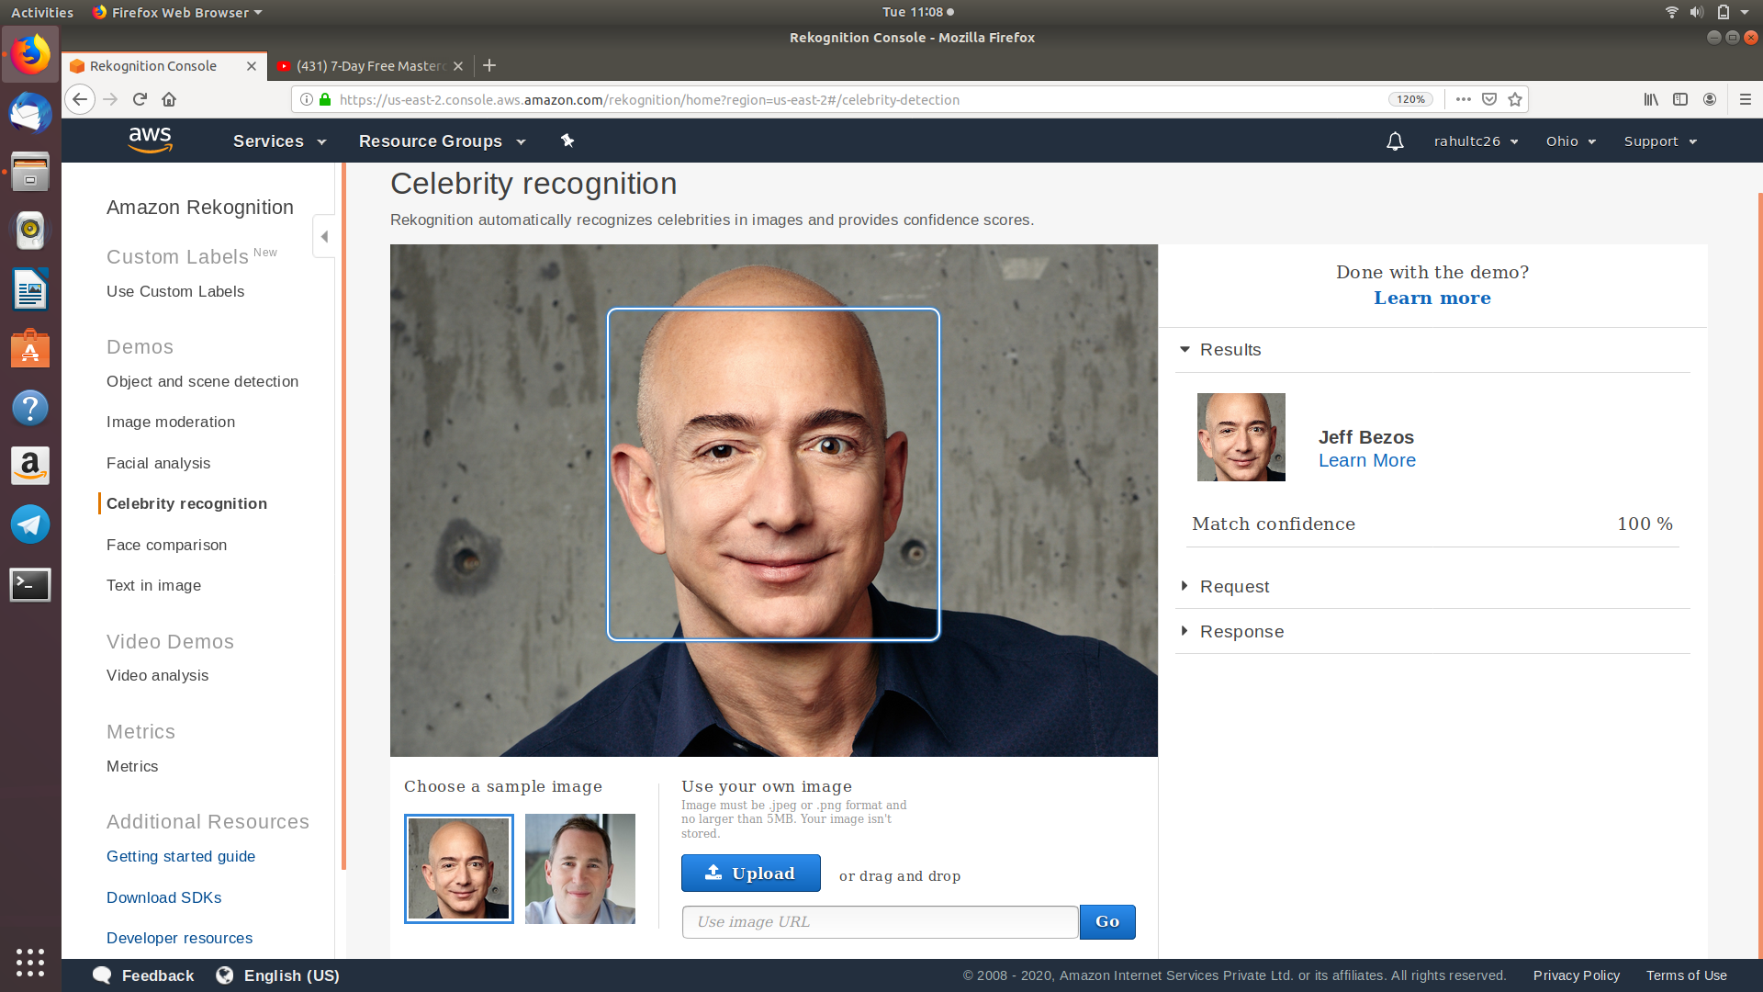

Screenshot:19 – Celebrity Rekognition

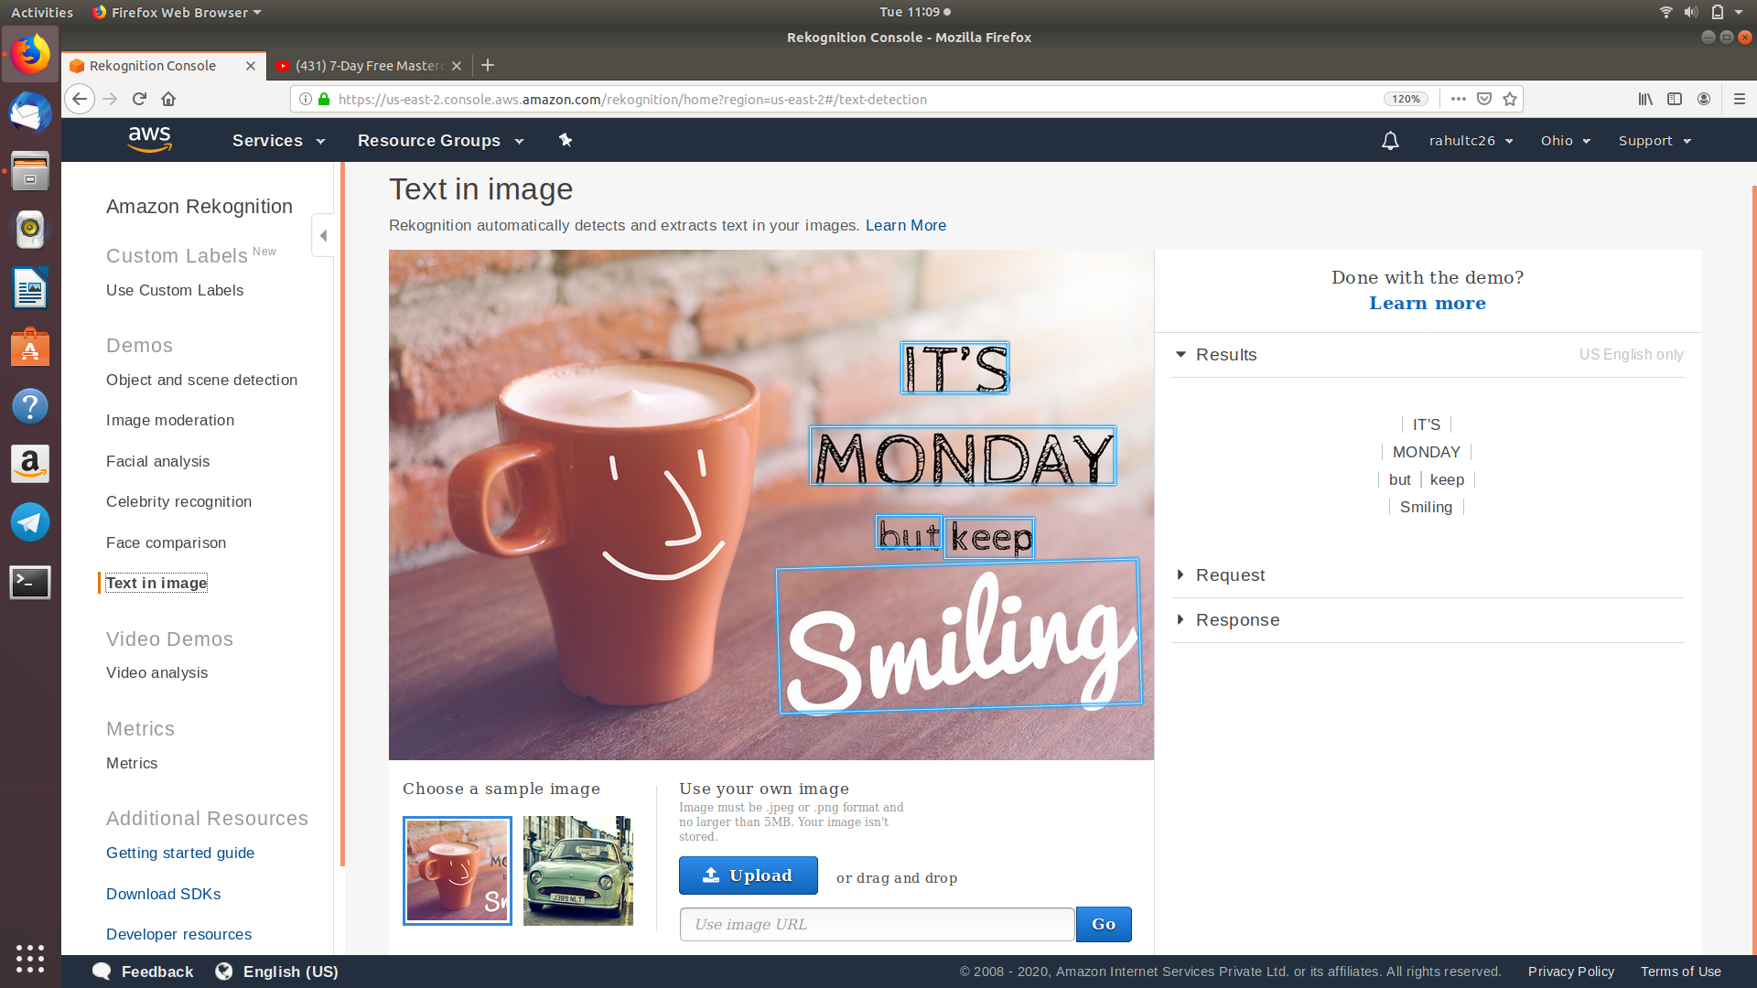

Screenshot:20 – Text In Image

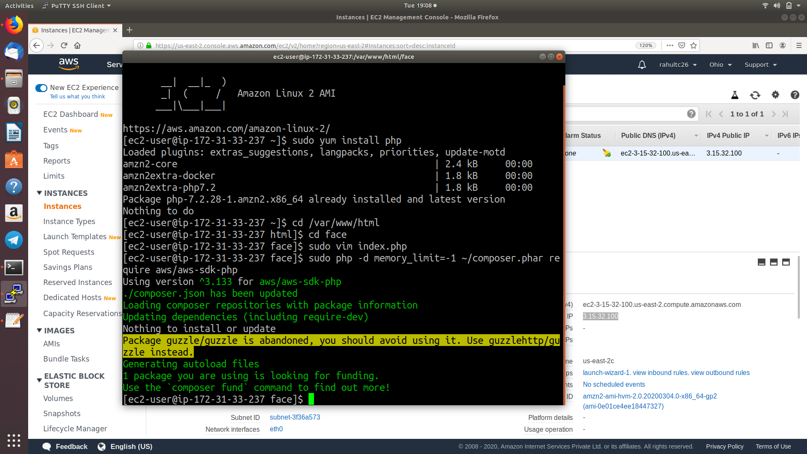

Screenshot:21 – Installing aws-sdk

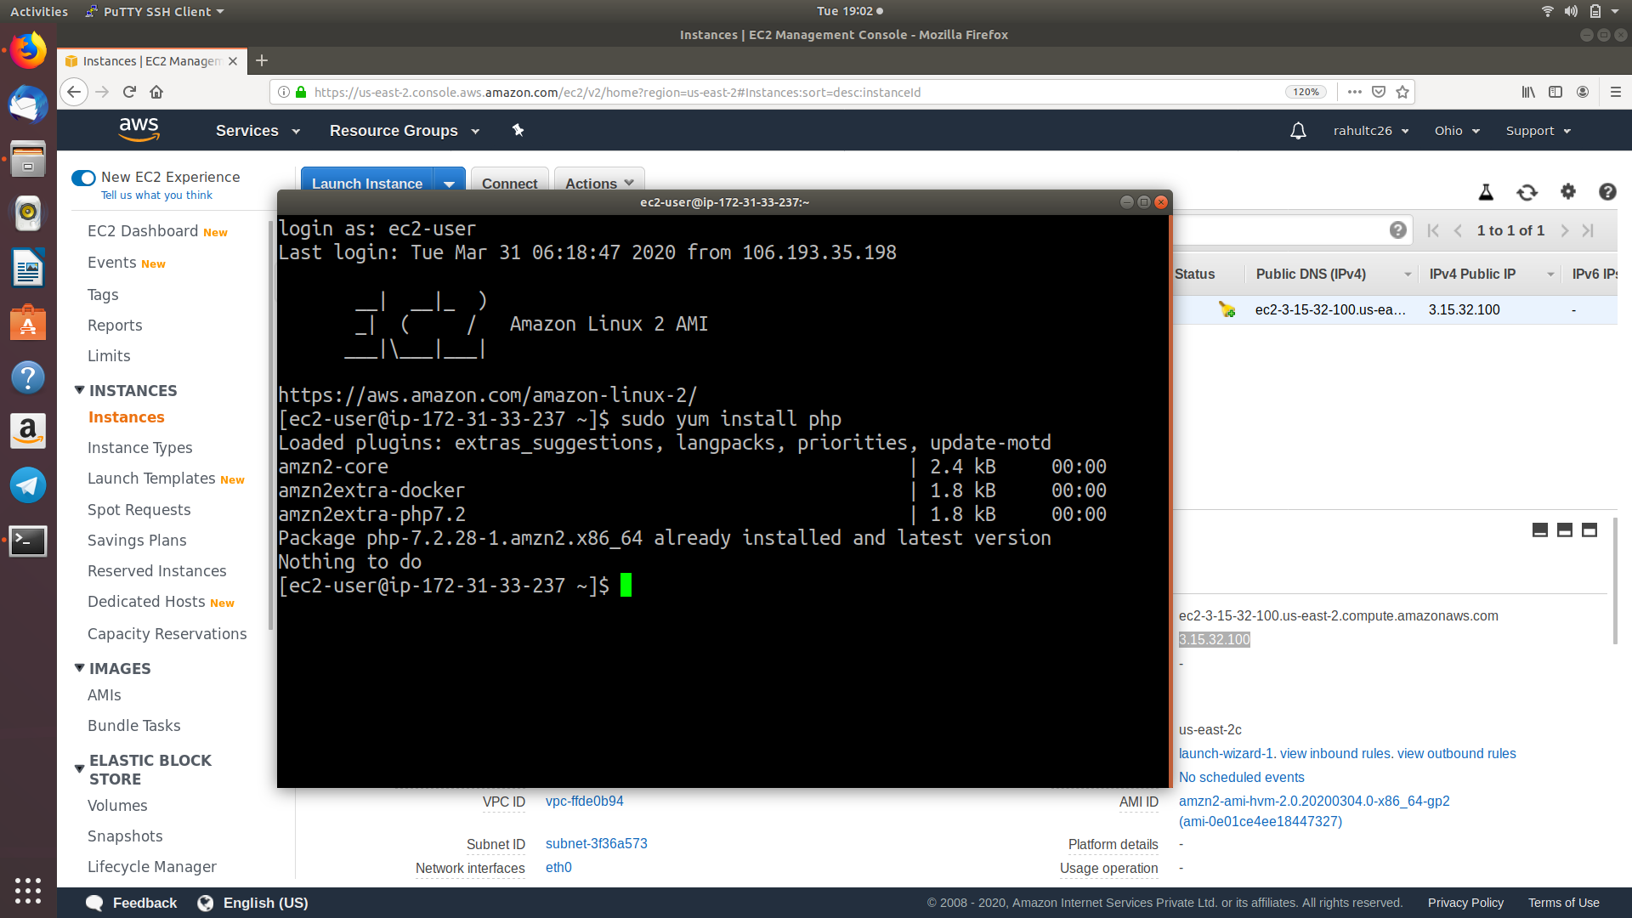

Screenshot:22 – Installing php

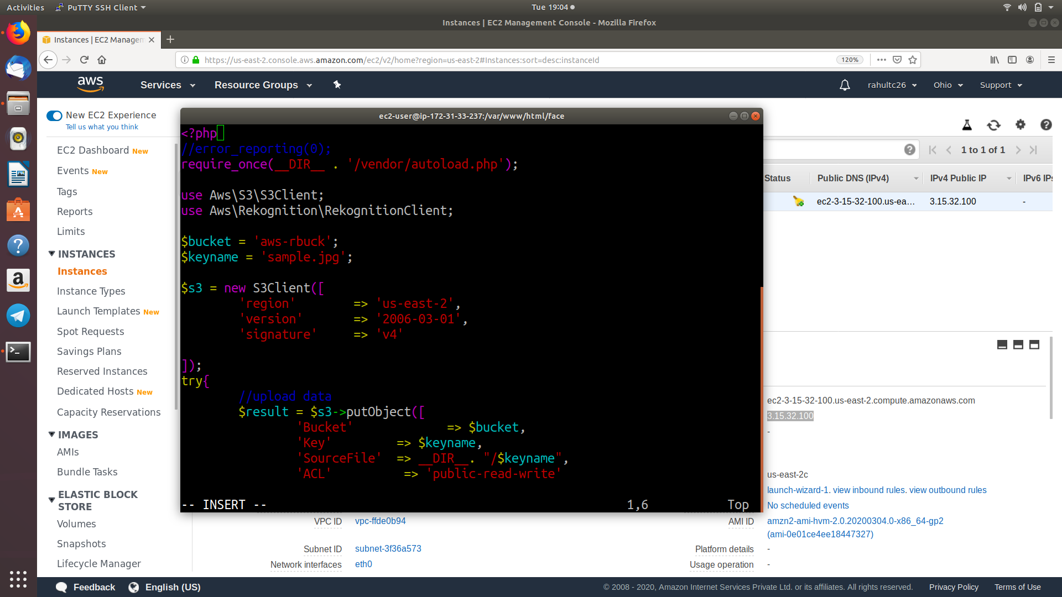

Screenshot:23,23.1 – Index.php(File)

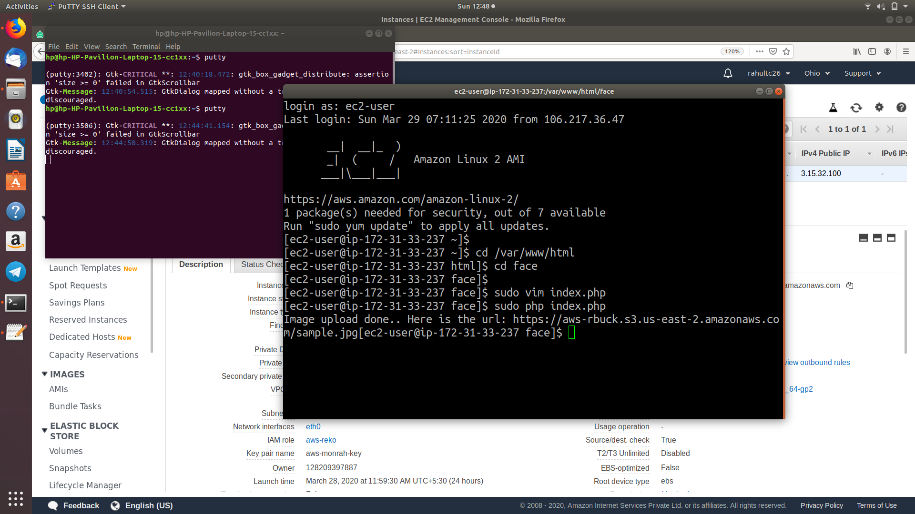

Screenshot:24 – Image Upload Success Screenshot with URL

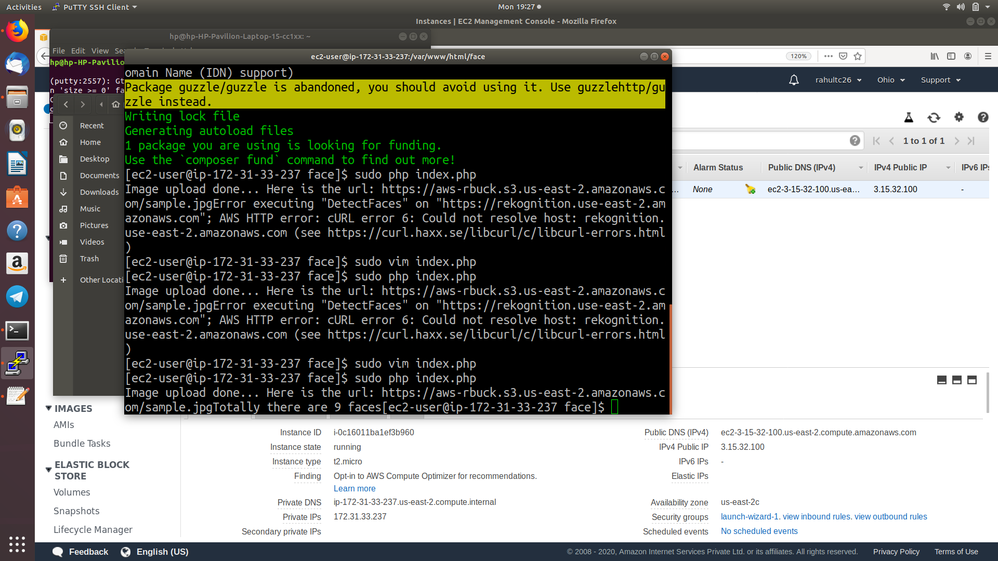

Screenshot:25 – Face Detect Success Screenshot